**Database schema**

***Introduction:***

Database is a collection of information that is organized so that it can be easily accessed, managed and updated. In this case, the database contains all the information about all employees listed in database, such as their First and Last Names, ID, project names and so on. Databases can be stored either on local machine, or on local server. In both cases, providing credentials for database access may be necessary. In particular case, the database is located on MySQL server.

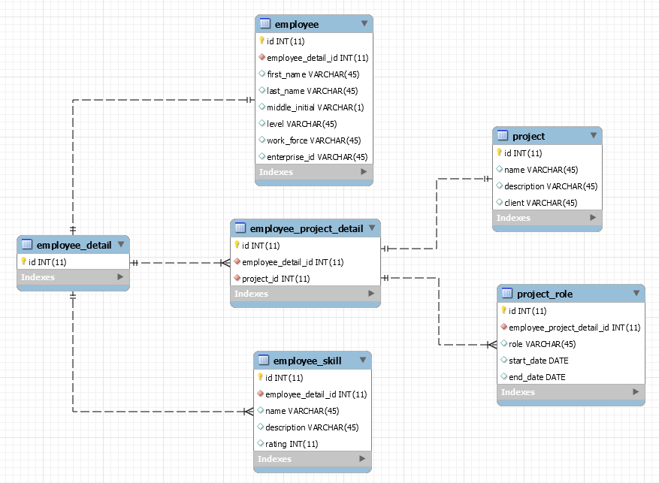

**Figure 1 Completed MySQL Database schema**

In order to access the database contents, there needs to be a program that can access and work with acquired data. Figure 1 shows that data in this database is ordered hierarchically. The main block is “Employee Detail” that contains 3 blocks: “Employee”, “Employee Project Detail” and “Employee Skill”. The block “Employee Project Detail” contains its own two blocks, namely “Project” and “Project Role”. Each specific folder and all its contents are put in use whenever a program requests them via user input.

The next page will cover each block and explain the contents of them.

***Contents of blocks:***

Each block contains data that, in turn, contains necessary information. The information of each data file is explained below. For clarification, frequently met definitions are explained just above Figure 2:

* VARCHAR(45) – Character type variable with a maximum length of 45 characters;
* DATE – Date type variable. Contains date and time;
* INT(11) – Integer type variable with a maximum length of 11 alphanumeric numbers;

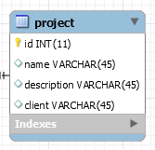

**Figure 2 Project block**

Figure 2 deals with the information about the project. The information provided is the project’s name, its description and client. All these fields are defined as character type variables.

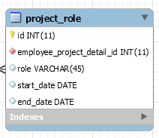

**Figure 3 Project Role block**

Figure 3 displays the information about a basic information about a specific project role. As it can be seen, the information provided is project’s role, which is a character type, as well as start/end date, that are Date type variables. “Start Date” indicates, when the project was started and “End Date” indicates, when the project was finished.

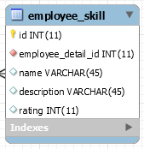

**Figure 4 Employee Skill block**

Figure 4 deals with the skills of an employee. The “Name” field indicates the name of a skill, e.g. skill in Java programming, and “description” field provides with short information about that skill. Both these skills are character variables. Then there is a “rating” field, which describes how well developed is the employee with particular skill. The “rating” is Integer type variable.

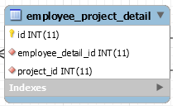

**Figure 5 Employee Project Detail block**

Figure 5 displays a collection of project roles of an employee for a specific project. Note that this block extends to “project” and “project role” blocks. The information provided here is “Employee Detail ID” that contains data about an employee through its ID number, and “Project ID” that contains data about the project through its ID number. Both pieces of information are Integer type variables.

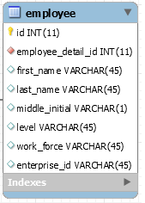

**Figure 6 Employee block**

Figure 6 deals with the basic information about a single employee. As it can be seen, this block contains the employee’s first and last name, as well as initial of middle name, for example, John. A. Atkinson. It also contains employee’s level, work force and enterprise ID. Note that all those fields are Character type variables. The reason why “Level” and “Enterprise ID” are Character type variables is because these fields do not have to necessarily contain only numbers, e.g. Level can be measured from A to F and Enterprise ID can be “0000AEE144”.

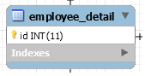

**Figure 7 Employee Detail block**

In Figure 7 the “Employee Detail” block displays a combination of the different domain objects. This represents information about a specific employee, the employee’s project history and the employee’s skill set. Referring to Figure 1, this is the main block which other blocks extend from.

Some blocks contained “Employee Detail ID” and “Employee Project Detail ID”. It means that aforementioned blocks provide with the information that is related with a corresponding Employee ID only. “Employee Project Detail ID” can provide information about projects through their IDs and, in turn, their writers – employees.

Also note the pink diamond-like bullets near some fields in various Figures. They represent the link between the blocks, meaning that more information can be acquired by navigating between blocks. From user’s perspective, by clicking on an employee’s name or project’s name.

The next page will cover an example of how the data can be gathered from this particular database.

***Examples of gathering data from database:***

Let’s take an example, when an employee Quinta K. Taverna needs to be found, but information about her projects and skills is not necessary (refer to Figure 1 for data traversal):

* in order to start searching for Quinta, her name needs to be typed in search bar and “Find By Name” button needs to be clicked;
* when done, the program traverses through the database and because the search was done through “Find By Name”, it will display the information from the “Employee” block (refer to Figure 6), namely her first/last name, middle name initial, level, work force and Enterprise ID;

Now let’s take a look when a detailed information about her (Quinta K. Taverna’s) projects is required;

* reproduce steps from an example above;
* additional information can be accessed by clicking on her name;
* when done, the information from “Employee Project Detail" block (refer to Figure 5) will be gathered, but because this block splits into “Project” and “Project Role” blocks (refer to Figures 2 and 3) the information from these blocks will be displayed and not from “Employee Project Detail” because in this block, there is nothing to display;

The final example will deal with searching via Project ID. Note that all projects listed in database can be selected via dropdown menu:

* in order to start searching, a project’s name must be selected and “Find By Project ID” button must be clicked;
* when done, the program traverses through “Project” and “Project Role” (refer to Figures 2 and 3), because so far it is not interested in particular employee;
* when finished, it displays a list of all employees that worked or have been working on particular project;
* the names of employees can be interacted with to reveal detailed information about them. This part is explained in the example above;

***Afterword:***

This is the example of the simple database structure. Right now it serves one purpose: providing the data should the program request it. The structure of the database is made so that all blocks are interconnected even though they do not have to be. Generally speaking, all the information is gathered at once, but only select pieces of information are displayed.